Weekly Accomplishments

* Met together and discussed plan of action
* Brainstormed what the program should do
* Brainstormed some Ideas on how it should look
* Divided up some work
* Created Step by step list of things we need to accomplish
* Created a means of communication (Google docs, Google hangout)
* Planned our next meeting
* Personally worked on a front end template
* Commit 1
* 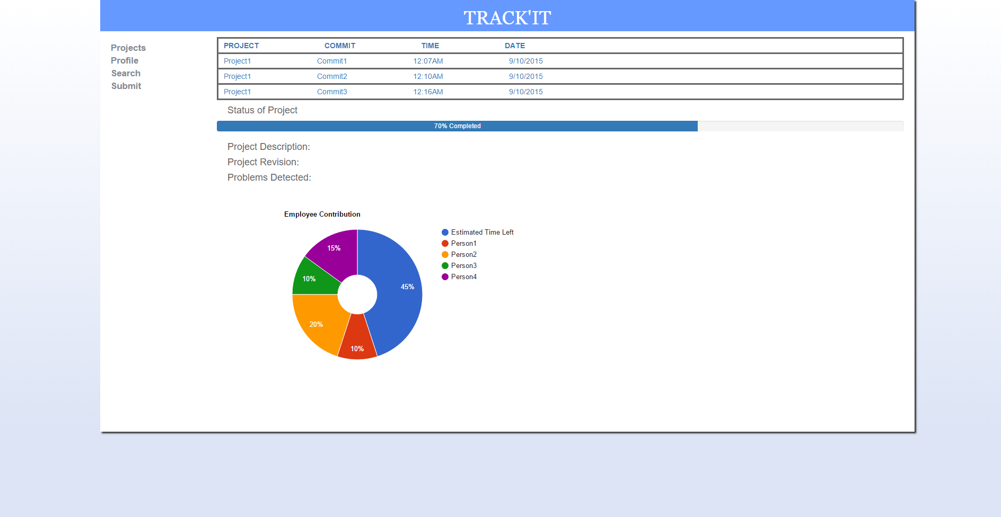
* Commit 2

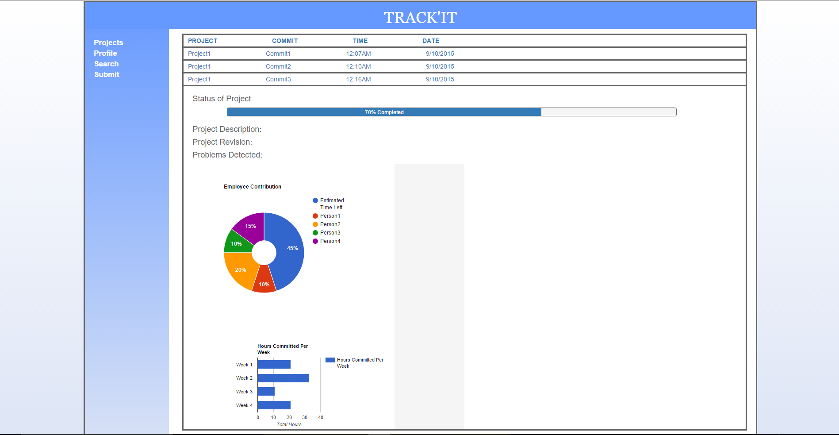

Commit 3

